**Project Development Phase**

**Sprint - 3**

|  |  |
| --- | --- |
| Date | 09 November 2022 |
| Team ID | PNT2022TMID42525 |
| Project Name | Classification of Arrhythmia by Using Deep Learning with 2-D ECG Spectral Image Representation |

**Local Deployment:**

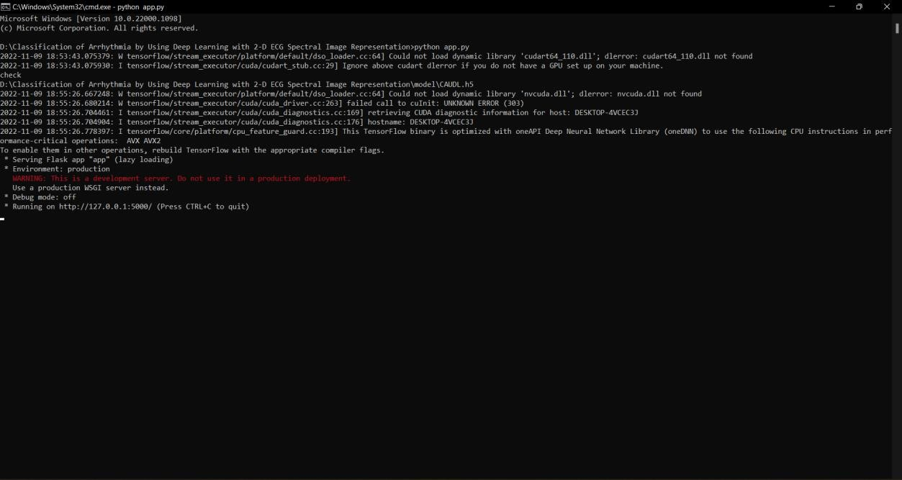

**( Running App ! – Flask )**

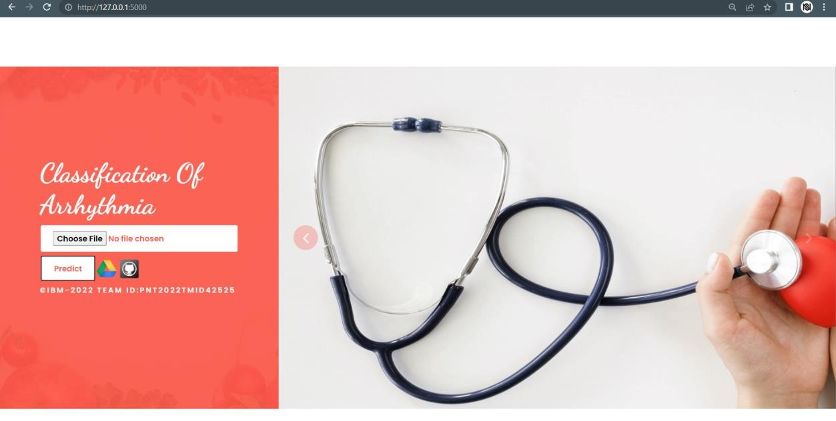

**( UI Application Opens Successfully.. )**

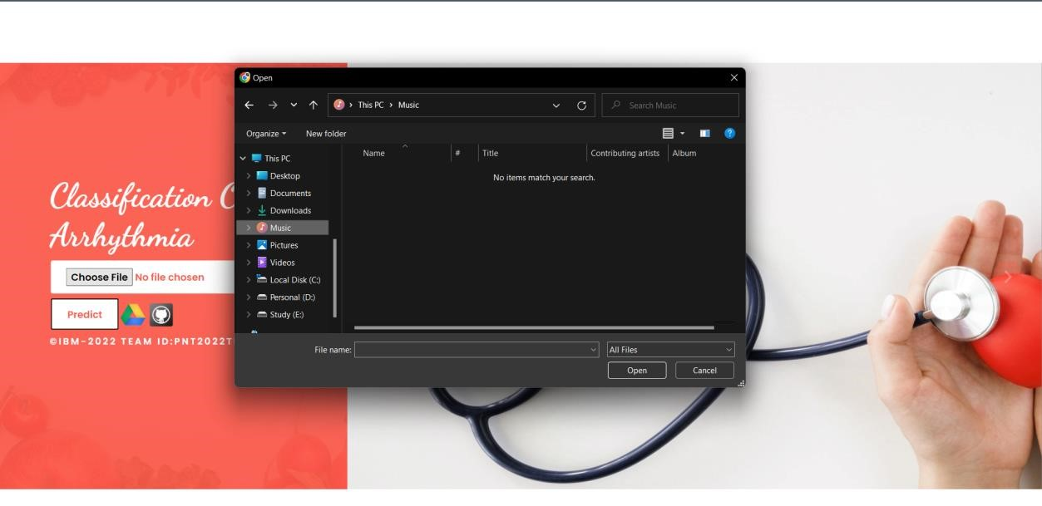

# ( Click Choose File To Upload Images )

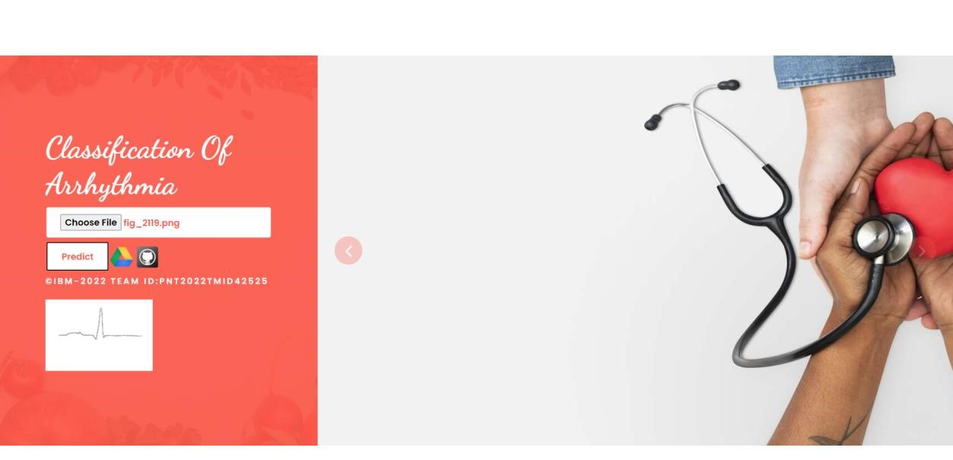

# ( The Image Is Uploaded – Click Predict Button To Predict )

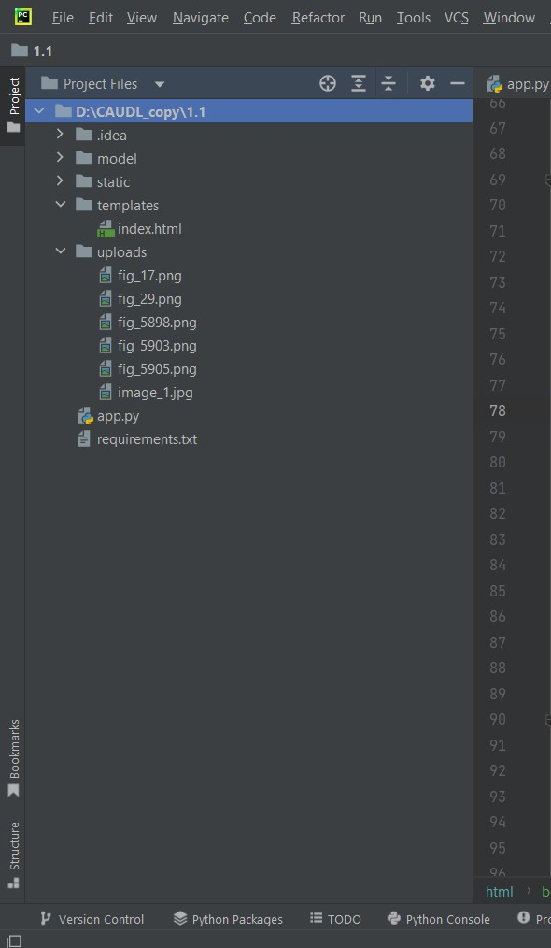

# ( The Uploaded Image Is Stored In The Uploads Folder !! )

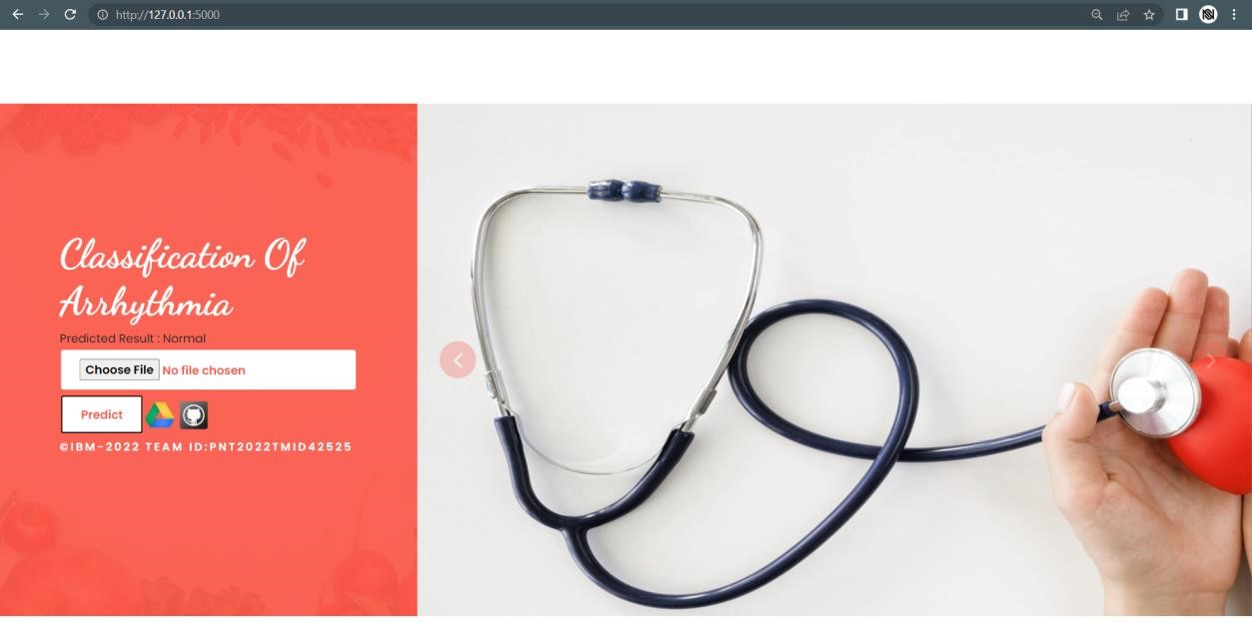

# ( Through “Predicted Result” The Image Classification Is Visible.. )



# ( Click Google Drive Button For Sharing Purposes )